## 

## **Practical-5**

**Student Name:** Gauri Prabhakar **UID:** 18BCS6201

**Branch:** 18AITAIML-2 **Section/Group:** B

**Semester:** 7 **Date of Performance:** 5th October, 2021

**Subject Name:** Computer Vision Lab **Subject Code:** CSF - 432

# Aim/Overview of the practical:

To implement handtracking using mediapipe in python and OpenCV.

# Task to be done:

To implement handtracking using mediapipe in python and OpenCV and the explanation.

# Steps to be followed:

1. Importing necessary modules.
2. Creating a variable to store the video using the '.VideoCapture()' function.
3. Importing 'mp.solutions.hands' to a variable 'mpsh'.
4. Declaring the object 'hands' from 'mp.solutions'.
5. Importing 'mp.solutions.hands' to a variable 'mpsdu'.
6. We will use 'drawing_utils' to draw the key points.
7. Capturing the video frame by frame using the '.read()' method.
8. Reading the frames and converting them to RGB.
9. Detecting hands in the frame using the function 'hands.process()'.
10. Printing the results.
11. If hands are detected that is 'results.multi_hand_landmarks' returns true:
12. For 'handLms' variable in 'results.multi_hand_landmarks':
13. Looping through the 'handLms' variable to find out the coordinates of each key point.
14. Printing the landmarks and 'ids'.
15. Declaring the variables 'h', 'w' and 'c'.
16. Declaring the variables of the 'x' and 'y' coordinates.
17. Numbering the key points.
18. Printing the 'id' and the coordinates of the key points.
19. Highlighting the key points.
20. Connecting the key points using the function 'mpsdu.draw_landmarks()'.
21. Rendering the video with effective Handtracking to the console by using the function '.imshow()'.
22. Setting up '.waitkey()' to wait for a specific time until any key is pressed and break the loop.
23. Implementing Hand Tracking using Live footage from the Webcam.
24. **Result/Output/Writing Summary:**

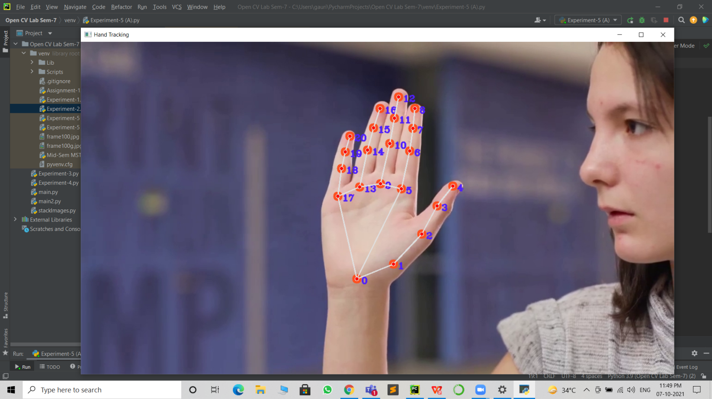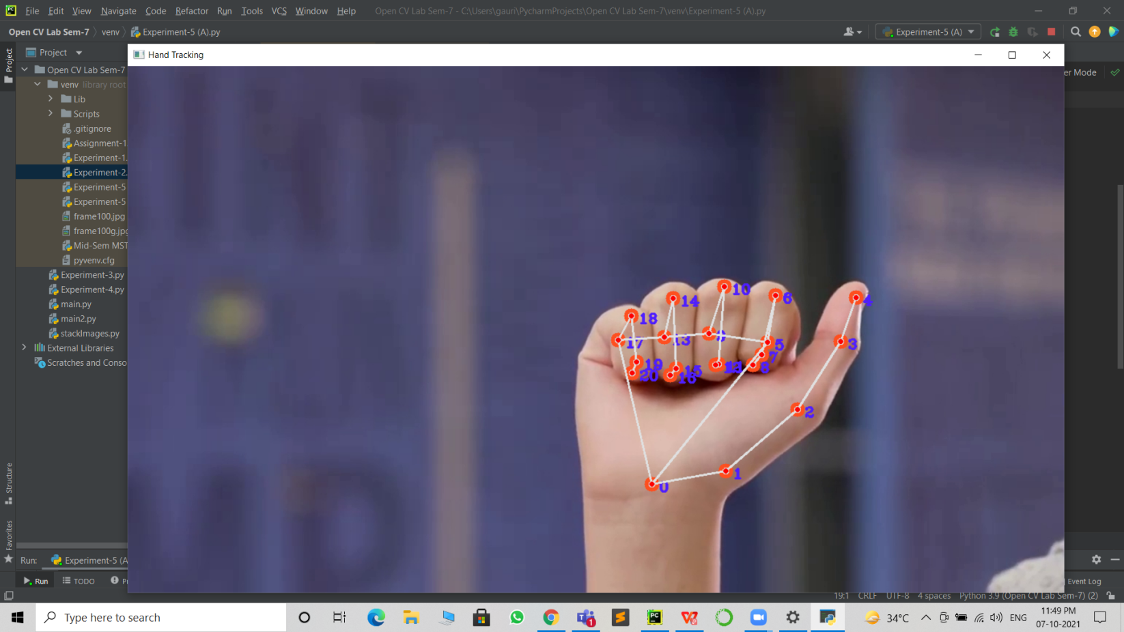

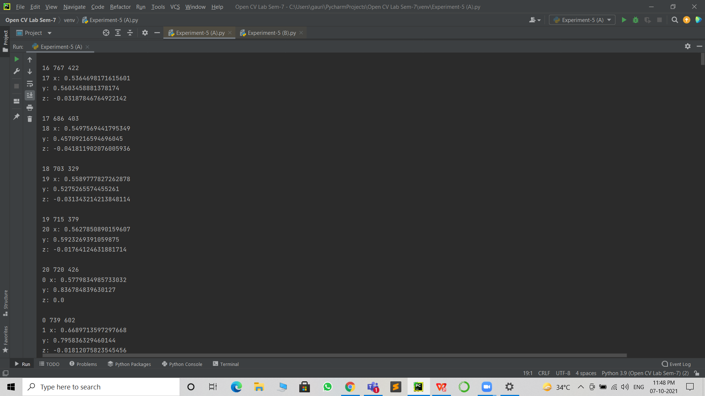

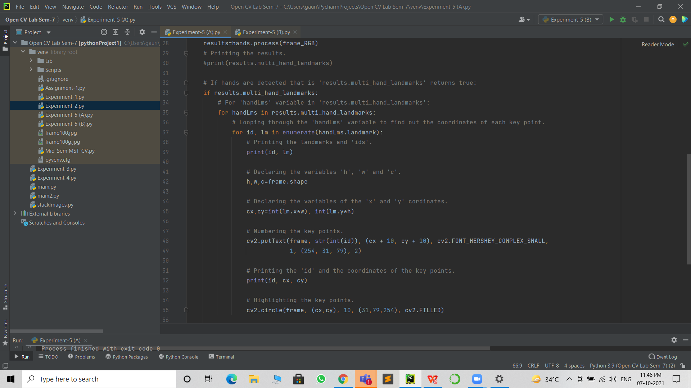

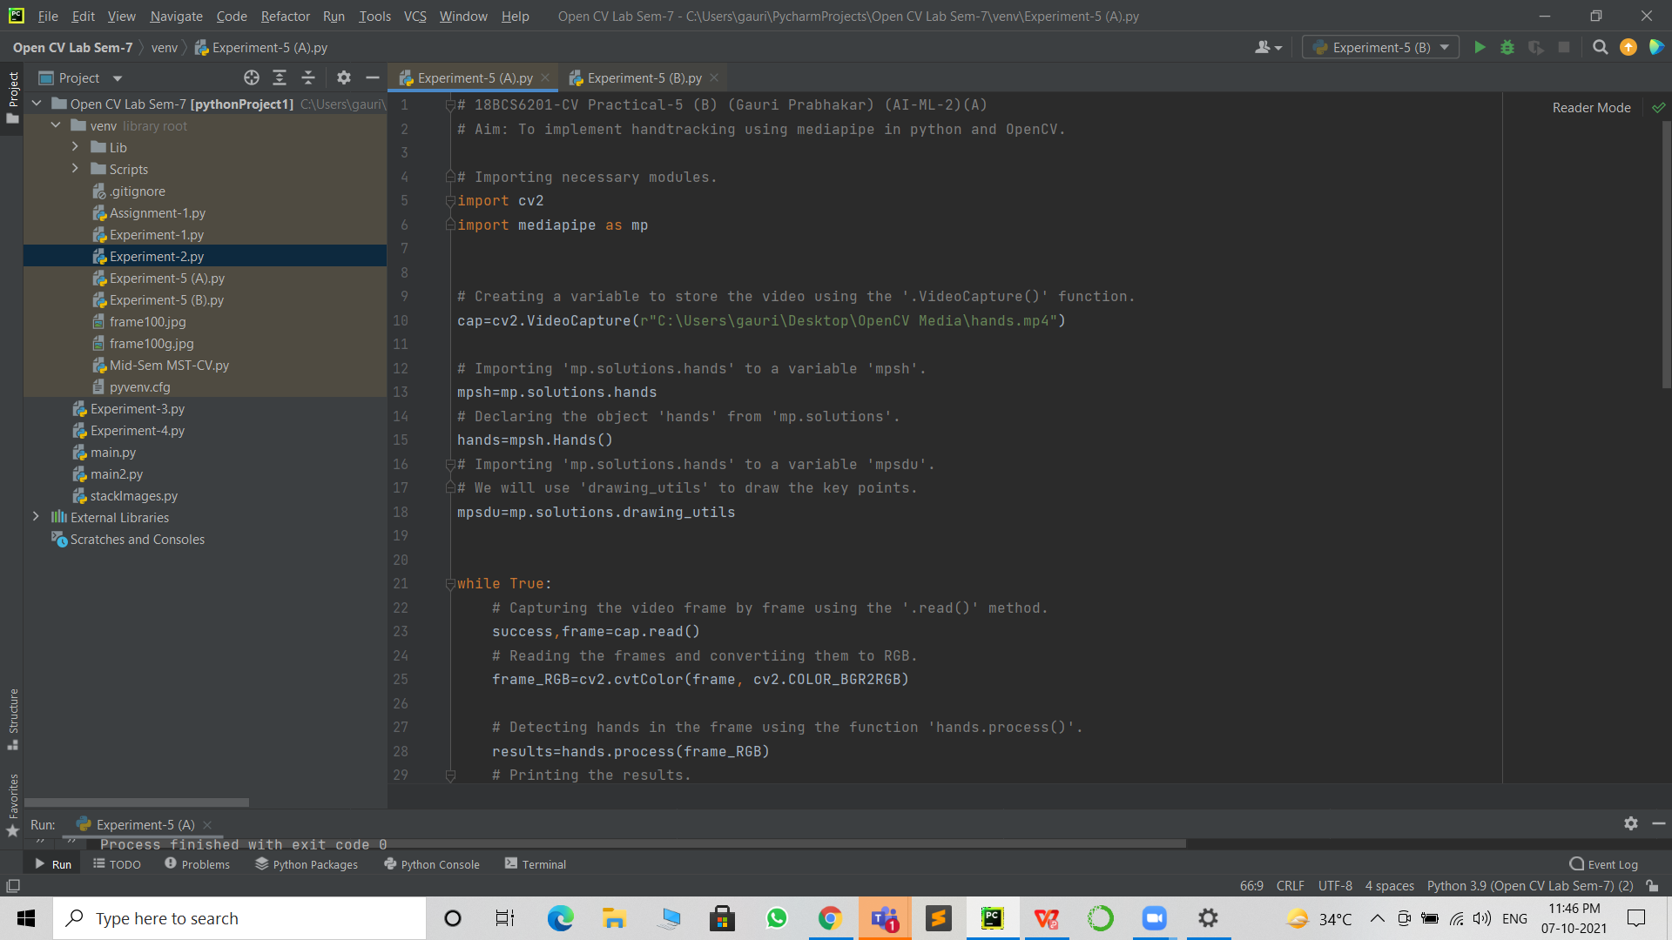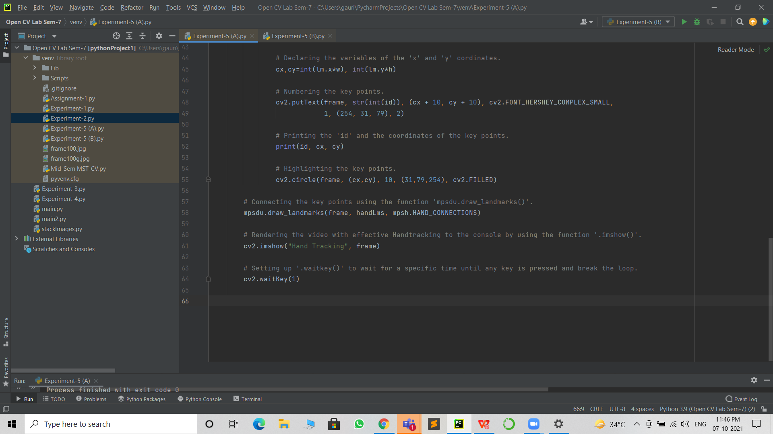

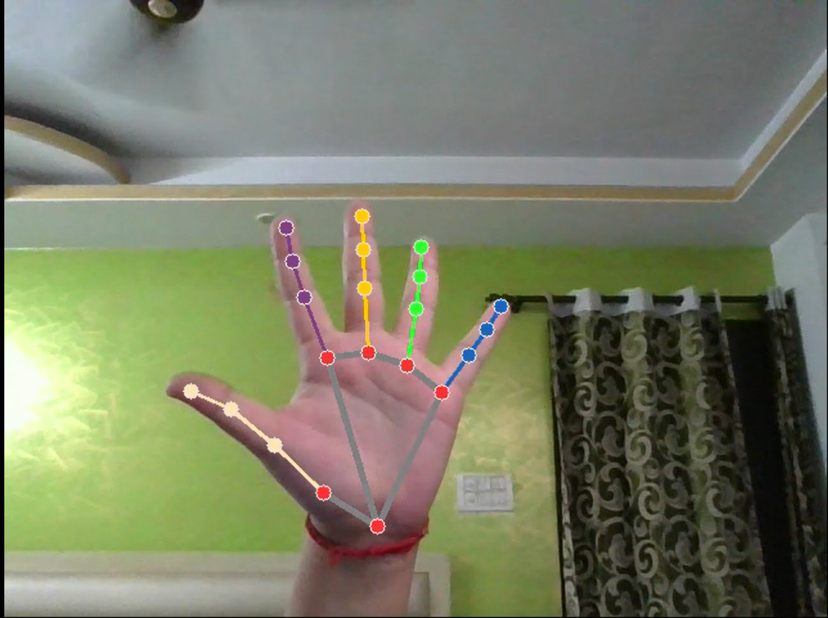

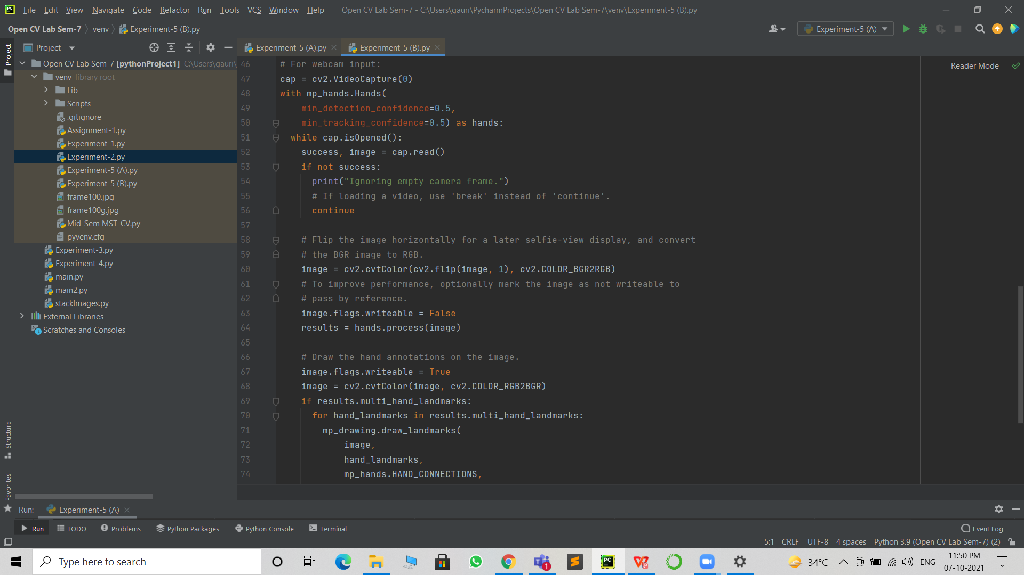

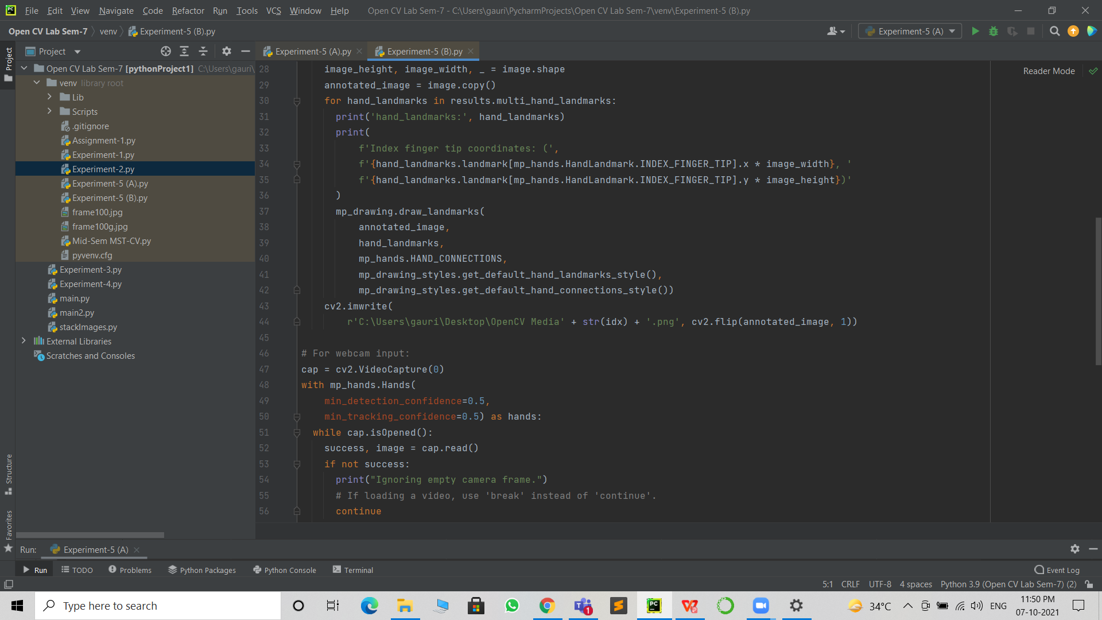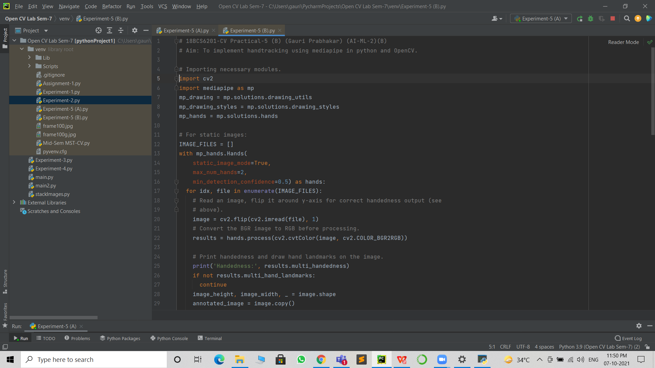

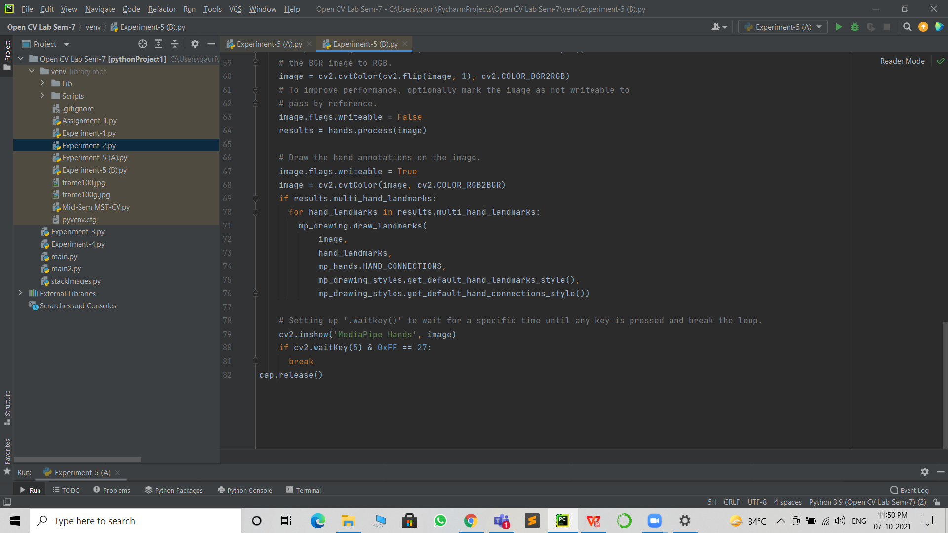

# Learning outcomes (What I have learnt):

* Open CV modules.
* The mediapipe library.
* Detect hands using the mediapipe library.
* Hand tracking a saved video.
* Hand tracking live video from the webcam.
* Highlighting key points.
* Labeling/numbering the key points.

**Evaluation Grid (To be created as per the SOP and Assessment guidelines by the faculty):**

|  |  |  |  |
| --- | --- | --- | --- |
| Sr. No. | Parameters | Marks Obtained | Maximum Marks |
| 1. |  |  |  |
| 2. |  |  |  |
| 3. |  |  |  |